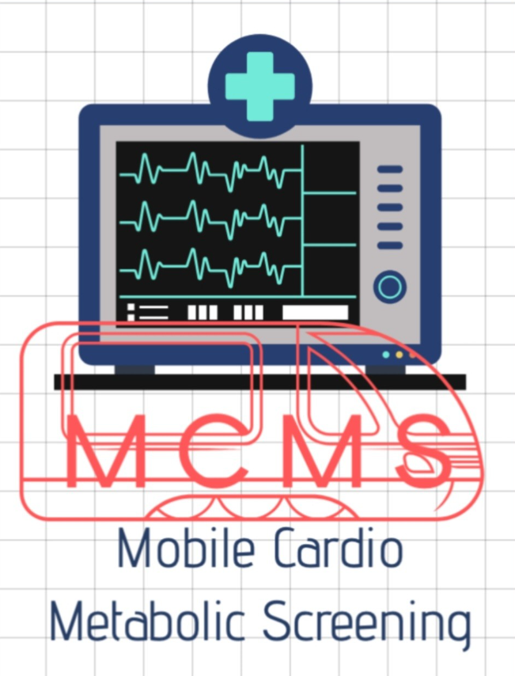
MCMS - A Project Model for Kerala through MKGA
“PREVENTION IS BETTER THAN CURE”
Detect Early • Prevent Complications • Protect Lives
(Shibu Peter
Engineer by Profession
Chairman, Peter Foundation Trust / Executive Member, PROP Charitable Society
Ambassador-Gift of Hope USA & Illinois Department of Public Health / Honorary Member- National Kidney Foundation, USA
Philanthropist & Rotarian, supporting underprivileged kidney patients in Kerala by donating dialysis machines through Rotary International grant and providing free dialysis with follow-up care.)
The Idea
Today, many people detect diabetes, high blood pressure, high cholesterol, obesity chronic kidney disease (CKD), cardiovascular disease etc. only after the disease has progressed or a serious complication occurs.
Families then have to spend substantial amounts on treatment, often for many years.
Even after major interventions such as a kidney transplant, complete recovery is often difficult
What if we could identify these diseases and risk factors much earlier?
The Mobile Cardio-Metabolic Screening (MCMS) Project aims to bring essential preventive screening closer to the people through a mobile screening caravan and a physical screening laboratory

From Treatment-Centered Healthcare to Prevention-Centered Healthcare
Kerala spends substantial resources on treating advanced diseases and their complications. Heart attacks, strokes, heart failure, kidney failure requiring dialysis, vascular disease and other chronic conditions can place a tremendous financial and emotional burden on families as well as the healthcare system.
We should therefore give much greater importance to early detection and prevention
If conditions such as hypertension, diabetes, abnormal cholesterol and early kidney or vascular disease are detected early, people can be guided toward lifestyle changes, appropriate medical treatment and regular follow-up before serious complications develop.
A WORKING MODEL AT PALA
I have already raised approximately INR 1.2 crore through sponsorship to establish a physical screening facility and a caravan mobile laboratory at my building premises in Pala, Kottayam.
The objective is to implement and demonstrate a practical working model in and around Pala, learn from its operation, and develop it as a model that Kerala can be considered for wider adoption.
Screening Services
The MCMS unit will provide screening that includes:
CBC, Complete Metabolic Panel and Lipid Profile
Lipoprotein(a) [Lp(a)]
Blood Glucose and HbA1c
Urine Microalbumin
Blood Pressure
Height, Weight, BMI and waist/hip measurements
ECG/EKG
Ankle-Brachial Index (ABI)
Ultrasound screening of carotid arteries, abdominal aorta and femoral arteries
Results will be provided to participants, abnormal findings will be explained, and those requiring further evaluation will be advised to seek appropriate medical care
Affordable Community Healthcare
The project will give particular attention to economically disadvantaged people.
Eligible BPL/economically disadvantaged individuals can receive the screening free of charge, while others may contribute a nominal fee or voluntary donation.
The mobile unit can take screening & detection medical camps to all panchayats, municipalities & to all communities throughout Kottayam District
We cannot prevent every heart attack, stroke, kidney disease or serious illness. But we can do much more to identify risk factors and silent disease before they become life-changing emergencies.
Kerala has an excellent healthcare network.
Let’s strengthen our existing healthcare system with stronger prevention and early detection system.
Proposal to the Government of Kerala
The Pala MCMS project can serve as a practical demonstration model for consideration by the Government
propose that Kerala consider developing a standardized Cardio-Metabolic Preventive Screening Program through Primary Health Centers (PHCs) across the state, supported by mobile screening units wherever required.
The vision is simple:
Screen early.
Detect early.
Treat early.
Prevent complications.
Protect lives.
Reduce the financial burden of disease.
From one model in Pala — to preventive healthcare across Kerala.

